**IOT_PHASE _4**

**AIR QUALITY MONITERING SYSTEM**

**ABSTRACT:**

Air pollution is a critical environmental concern with significant health and environmental consequences. To address this issue, an Internet of Things (IoT) based air quality monitoring system has been developed. This system utilizes a network of low-cost sensors to continuously collect real-time data on various air pollutants, including particulate matter (PM2.5 and PM10), volatile organic compounds (VOCs), carbon monoxide (CO), nitrogen dioxide (NO2), and ozone (O3).

The IoT-based air quality monitoring system consists of sensor nodes deployed across urban and industrial areas, collecting data at regular intervals. These sensor nodes are equipped with advanced sensors capable of measuring air quality parameters accurately. The collected data is transmitted to a central server through wireless communication protocols such as Wi-Fi or cellular networks.

The central server processes and analyzes the incoming data, generating real-time air quality indices and pollution maps. These indices provide valuable information to both government agencies and the general public. Users can access this information through a user-friendly web interface or a mobile application, enabling them to make informed decisions regarding outdoor activities and health precautions.

Furthermore, this system offers the capability of predictive modeling, allowing authorities to anticipate pollution levels based on historical data and meteorological factors. This enables the implementation of timely interventions to mitigate air pollution.

In conclusion, the IoT-based air quality monitoring system represents an effective and scalable solution for addressing air pollution challenges. By providing real-time data and predictive capabilities, it empowers individuals, communities, and governments to take measures to improve air quality, reduce health risks, and protect the environment. This technology contributes to building smarter and healthier cities while promoting sustainability and public awareness about the importance of clean air.

**INTRODUCTION:**

* Air Quality Monitoring Networks allow the measurement, operation and predictive analysis of the evolution of air pollution in different areas (urban areas, industrial areas, special nature conservation areas, etc.) Some stations are equipped with meteorological sensors and/or noise level meters to measure noise levels**.** Air quality is a critical environmental factor that affects the health and well-being of individuals and the quality of life in urban and industrial areas. Poor air quality can lead to a range of health issues, including respiratory problems, cardiovascular diseases, and even premature death. To address these concerns, the development of effective air quality monitoring systems has become increasingly important.
* IoT (Internet of Things) technology has revolutionized the way we collect and analyze data from the physical world. IoT-based air quality monitoring systems leverage this technology to provide real-time, accurate, and granular information about air quality in various locations. These systems use a network of interconnected sensors, data processing, and communication devices to continuously monitor the concentration of various air pollutants.

**BLOCK DIAGRAM:** 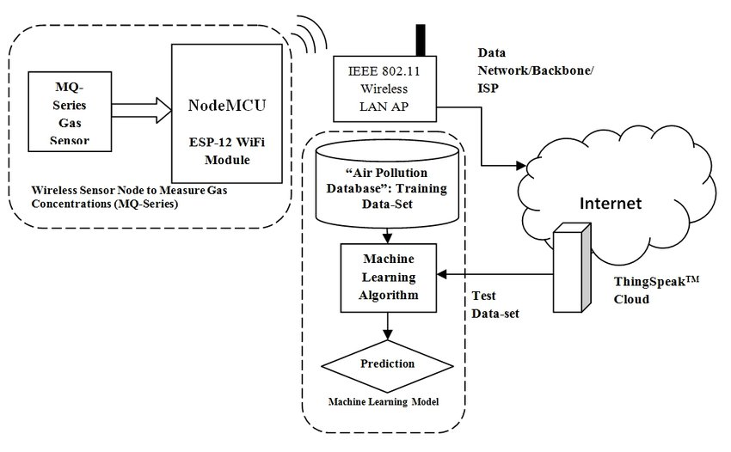

**IoT Monitoring System components:**

IoT-based air pollution monitoring systems comprise several components that work together to collect and analyze air quality data. The components include:

* **Sensors**: Sensors are the primary components of IoT-based air pollution monitoring systems. They measure various air quality parameters such as particulate matter, carbon monoxide, sulfur dioxide, and nitrogen oxides. The sensors can be classified into two categories: physical and chemical sensors. Physical sensors measure parameters such as temperature, humidity, and pressure, while chemical sensors measure air pollutants.
* **Microcontroller:** The microcontroller is the brain of IoT-based air pollution monitoring systems. It receives data from the sensors, processes it, and sends it to the cloud server. The microcontroller is usually a microprocessor such as Arduino, Raspberry Pi, or similar devices.
* **Communication Module:** The communication module is responsible for transmitting data from the microcontroller to the cloud server. Communication modules can use various wireless technologies such as Wi-Fi, Bluetooth, or cellular networks.
* **Cloud Server:** The cloud server is a centralized platform for storing, analyzing, and sharing air quality data. It collects data from the communication module and stores it in a database. The cloud server also provides web and mobile applications for users to access the data.
* **Power Supply:** IoT-based air pollution monitoring systems require a power supply to operate. In case of permanent installations external power supply is provided and batteries are provided for portable devices.
* **Enclosure:** The enclosure is the outer covering that protects the components from environmental factors such as dust, water, and temperature.

**Benefits of IoT-Based Air Quality Monitoring:**

* **Real-Time Monitoring:** IoT-based systems provide continuous and real-time air quality data, allowing for prompt responses to deteriorating air quality.
* **Data Accuracy:** Sensors used in IoT systems are typically more accurate and reliable than traditional monitoring methods.
* **Data Accessibility:** Data is readily accessible to the public, researchers, and policymakers, promoting transparency and informed decision-making.
* **Identifying Pollution Sources**: These systems can help identify specific sources of pollution, enabling targeted interventions to mitigate air quality issues.
* **Public Awareness**: By making air quality data accessible, IoT-based systems raise public awareness about the importance of air quality and encourage individuals to take measures to protect their health.
* **Environmental Policy**: Governments and local authorities can use the data collected to formulate effective environmental policies and regulations.

**WEB DEVELOPMENT USING HTML:**

<!DOCTYPE html>

<html>

<head>

<title> Air Quality Data</title>

<link rel="stylesheet" href="style.css">

</head>

<body>

<h1><font color="red"><center>SHREE VENKATESHWARA HI-TECH ENGINEERING COLLEGE</font></h1>

<center><img src="file:///C:/Users/LEGEND%20USER%205470/Downloads/download.jfif"></center>

<h1><font color="black"><a href="">Air Quality Data</a></center></font></h1>

<center><img src="file:///C:/Users/LEGEND%20USER%205470/Downloads/logo.png"></center>

<script src="script.js"></script>

<left><p><h2>TEAM MEMBERS</h2><h3>J.Aravindh</h3></p><left>

<h3>V.Naveen</h3>

<h3>D.Gokulraj</h3>

<h3>M.Indhuja</h3>

<h3>R.Srilekha</h3>

<h3>S.Vijiyasri</h3>

</body>

</html>

**OUTPUT:**

# SHREE VENKATESHWARA HI-TECH ENGINEERING COLLEGE



# Air Quality Data



## TEAM MEMBERS:

### J.Aravindh

### V.Naveen

### D.Gokulraj

### M.Indhuja

### R.Srilekha

### S.Vijiyasri